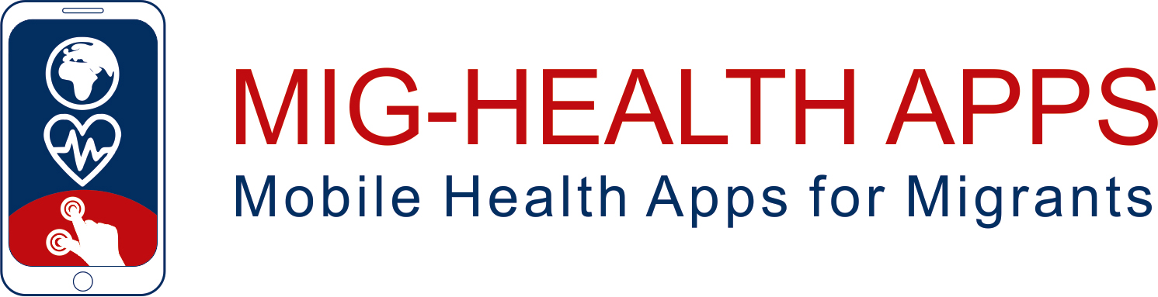

**Experiential Training Activities**

**ETA 1**General awareness on the relevance of self-management and Health apps

**Authors**

Laura Llop Medina, Polibienestar Research Institute, UVEG

Alfonso Gallego Valadés, Polibienestar Research Institute, UVEG

Guillem Part Lopez, Polibienestar Research Institute, UVEG



|  |  |
| --- | --- |
|  | Funded by the European Union. Views and opinions expressed are however those of the author(s) only and do not necessarily reflect those of the European Union or the European Education and Culture Executive Agency (EACEA). Neither the European Union nor EACEA can be held responsible for them. |

**Declaration on Copyright:**

**Εικόνα που περιέχει κείμενο, clipart

Περιγραφή που δημιουργήθηκε αυτόματα**

This work is licensed under a Creative Commons Attribution-NonCommercial-ShareAlike 4.0 International License. You are free to:

* share — copy and redistribute the material in any medium or format
* adapt — remix, transform, and build upon the material

under the following terms:

* Attribution — You must give appropriate credit, provide a link to the license, and indicate if changes were made. You may do so in any reasonable manner, but not in any way that suggests the licensor endorses you or your use.
* NonCommercial — You may not use the material for commercial purposes.
* ShareAlike — If you remix, transform, or build upon the material, you must distribute your contributions under the same license as the original.

Content

1 About the Module 2

Objectives 2

Participants and roles 2

Learning outcomes 2

Training Contents: 2

Estimated duration 3

Resources 3

2 Training Content 4

2.1 Teaching Session 4

2.2 Experiential training session 5

2.3 Self-learning supported by online training tools 7

2.4 Closure session 7

3 Bibliography 8

# About the Module

Objectives

This module aims to raise awareness of the relevance of health self-management for migrants by helping them to understand the main concepts related to health applications and h ow they can be useful for migrants and for each individual. It also aims to motivate students to engage in the next phases of the project and to develop the basic digital competences to operate in the Health Apps environment.

Participants and roles

* Newcomer migrants; trainees who are interested in understanding the main concepts related to health apps and how they can be useful for self-management of their health.
* Migrants Peers; learners or trainers after being trained as trainers. When they will attend as trainees, they could play a role of supporting the Newcomer Migrants along the training process, including support in overcoming language barriers.
* Supports: learners or trainers after being trained as trainers. When they will attend as trainees, they could play a role of supporting the Newcomer Migrants along the training process, including support in overcoming language barriers.

Learning outcomes

* Learners will be able to identify the health areas more relevant for them.
* Learners will be able to identify the main areas where their health self-management can be reinforced
* Learners will know what a Health App is and how they can be useful for migrants and for each individual person

Training Contents:

* Health Self-Management
* Main healthcare areas
* What is a Health App and examples
* How Health Apps can support the Health Self-Management
* Basic Digital Skills

Estimated duration

* Teaching session: 1:30 hours
* Self-learning supported by online training tools: 2 hours
* Experiential training session: 3 hours
* Closing session: 1 hours

Resources

* Training materials: ppt. for Teaching Session with 30-40 slides
* Training Materials: assignments, quizzes
* e-Training Platform and App Training Tool
* Health Apps: Examples of Health Apps covering different areas and functions
* Other: Complementary readings, videos (“youtube”) contents and tool from existing projects

# Training Content

## Teaching Session

| Step and duration | Content |
| --- | --- |
| 1.1.1 Introduction to health-self management for migrants  30 minutes | The trainer will shortly introduce the Health Apps project to the learners and then will highlight the relevance of the health-self management for migrants  This introduction will highlight the following aspects:   * Health Apps project short introduction * Icebreaker Activity * The importance of health-self management and how it can help prevent or manage some health problems   Resources: PPT |
| 1.1.2 Main concepts on Health Apps and Mig-Health Apps programme  30 minutes | The trainer will provide to learners’ the concept of health apps and the different types of applications covered by the programme. The trainer will show the Mig-Health Apps training programme and all the possibilities and ETAs contained in it.  The session will cover the following topics:   * Identify and categorise health apps * Identifying health apps that can be useful * Activity: The trainer will show the Mig-Health Apps training programme and learners will be able to discuss it and express their doubts or questions.   Resources: PPT |
| 1.1.3 Navigating Health Apps  30 minutes | The participants will have the opportunity to navigate to different health apps choosing from any of the ETAs developed in the project. More specifically, participants will:   * Go through different health apps. * Navigate through app interfaces, exploring core features and settings. * Activity: Participants will discuss and critically evaluate in pairs each health app they used.   Resources: PPT |

## Experiential training session

| Step and duration | Content |
| --- | --- |
| 1.2.1 Interactive Health Activity Challenge  1: 30 hour | The trainer will ask the learners to engage in a health challenge using one of the health applications offered in Mig-Health Apps. For example, using a health app for a week to improve emotional control.  This activity will be performed as follows:   * The trainer will upload information about the activity on the online training platform so that participants can do this activity asynchronous. * Trainer will provide different health challenges according to the interests expressed by the learners (ETAs) and each participant will choose one. * After participants have chosen the challenge, they will then need to use a health app and execute the challenge. * After participants complete their challenge, they will share their experience and lessons learned through uploading a short video or comment on the online training platform.   The trainer will check the completion of the above activity and will respond to each challenge.  Resources:   * Online Training Platform, PPT |
| 1.2.2 Real Life Integrations  30 minutes | The trainer will provide to learners’ several real-life scenarios and situations of how health apps have help individuals’ health in general.   * Presentation of different real-life scenarios where health apps could be beneficial (some of the apps of the ETAs of the project will be presented)   Resources: PPT |
| 1.2.3 Action Planning and goal setting for your Health  60 minutes | The trainer in this session will highlight the importance of action planning and goal setting in using apps for maintaining or improving migrant’s health.  Specifically, the topics to be addressed will be:   * How and why to action plan and setting goals (what? how? Which activity? where? when? duration? intensity? volume? App?). * Benefits of action planning and goal setting. * Activity: participants will set health goals. Participants then will create their own action plan based on the material that was presented. Each participant will then have 5 minutes to present their own action plan.   Resources: PPT |

## Self-learning supported by online training tools

|  |  |
| --- | --- |
| Step and duration | Content |
| 1.3.1. Self-Assessment  2 hours | The trainer will ask the learners to complete a Quiz in the e-Training Platform. The Quiz will help the learners in assessing:   * Importance of health-self management for migrants * What a Health App is and how they can be useful for migrants * Integration of health apps in daily life * Action Planning   The trainers will check the completion of the multiple choice and will support each learner depending on their main gaps.  Resources:   * Quiz. Online Training Platform |

## Closure session

|  |  |
| --- | --- |
| Step and duration | Content |
| 1.4.Closing  1 hour | This part includes a summary of main lessons learned from the training. Trainers facilitate a discussion based on individual experiences during self-learning and experiential training sessions to draw conclusions on perceived benefits of using health apps.  Resources:   * PPT |

# Bibliography

Kampmeijer, R., Pavlova, M., Tambor, M., Golinowska, S., & Groot, W. (2016). The use of e-health and m-health tools in health promotion and primary prevention among older adults: a systematic literature review. *BMC health services research*, *16*, 467-479.

Biswas, M., Tania, M. H., Kaiser, M. S., Kabir, R., Mahmud, M., & Kemal, A. A. (2021). ACCU3RATE: A mobile health application rating scale based on user reviews. *PloS one*, *16*(12), e0258050.

Ahmed, I., Ahmad, N. S., Ali, S., Ali, S., George, A., Danish, H. S., & Darzi, A. (2018). Medication adherence apps: review and content analysis. *JMIR mHealth and uHealth*, *6*(3), e6432