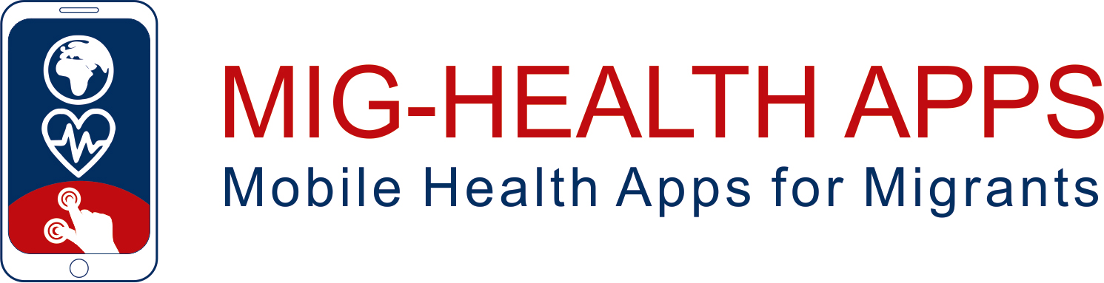

**WELCOME HANDBOOK**

**Authors**

|  |  |
| --- | --- |
|  | Funded by the European Union. Views and opinions expressed are however those of the author(s) only and do not necessarily reflect those of the European Union or the European Education and Culture Executive Agency (EACEA). Neither the European Union nor EACEA can be held responsible for them. |

**Declaration on Copyright:**

**Εικόνα που περιέχει κείμενο, clipart

Περιγραφή που δημιουργήθηκε αυτόματα**

This work is licensed under a Creative Commons Attribution-NonCommercial-ShareAlike 4.0 International License. You are free to:

* + - * share — copy and redistribute the material in any medium or format
      * adapt — remix, transform, and build upon the material

under the following terms:

* + - * Attribution — You must give appropriate credit, provide a link to the license, and indicate if changes were made. You may do so in any reasonable manner, but not in any way that suggests the licensor endorses you or your use.
      * NonCommercial — You may not use the material for commercial purposes.
      * ShareAlike — If you remix, transform, or build upon the material, you must distribute your contributions under the same license as the original.

Content

1 WHAT WILL YOU FIND HERE 1

2 WHAT ARE HEALTH APPS AND HOW THEY CAN HELP US? 2

3 TIPS FOR DOING WELL 3

4 HEALTH AREAS IN WHICH HEALTH APPS CAN BE USEFUL 4

# WHAT WILL YOU FIND HERE

Hello and welcome!! For sure you know that there are more and more digital tools aiming to help people in doing a better health management and care of themselves and their families. Among them, **health apps** are very accessible tools which can be easily used through your mobile phone.

Do you want to know more about them? What health apps are better than others depending on your own interests? How should you properly use them avoiding undesired problems?

https://www.pexels.com/de-DE/lizenz/

If you´re interested in such questions, you´re in the right place!! We invite you to read this handbook and extend the information in the training materials available on our project website (<https://training.apps4health.eu/>) and [training app](https://play.google.com/store/apps/details?id=gr.connexions.apps4health) (for Android only).

# WHAT ARE HEALTH APPS AND HOW THEY CAN HELP US?

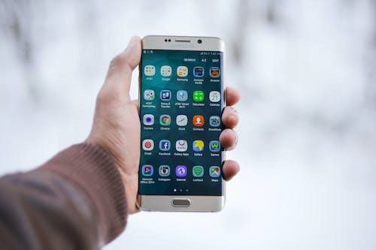Health apps are applications designed to support and improve users’ health, well-being and medical management. Health apps can promote health and primary disease prevention and help people with chronic diseases to manage their medical conditions or improve treatment adherence.

https://www.pexels.com/de-DE/lizenz/

They can tell you, for instance, about your pulsations, recommended diets, the quality of your sleeping time or help you in managing stressful situations. Summarizing, they can help you in a lot of health-related situations. Let´s move to the following sections to see more in detail how to use them.

# TIPS FOR DOING WELL

[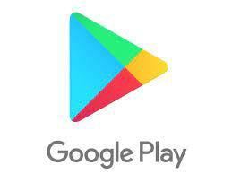](https://play.google.com/store/games?hl=es_419)[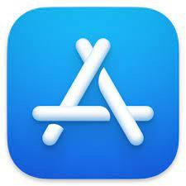](https://www.apple.com/app-store/)First, it´s very important to know some basic tips about how to use the Health Apps, in order to take benefit from them. Here you have some of them.

* Where and how to search for health apps? Google Play Store (Android); App Store (Apple)
* Select validated health apps in order to escape from misinformation, as there are apps which may bundle poor or even incorrect information
* Select health apps with a good app design, because a poor design such as an unfriendly user interface, may lead to infrequent usage
* Take care with your personal data. Health apps may require sensitive personal data in order to be used and function properly.
* Test several apps before committing (for example via a subscription)
* These applications do not replace consultations with doctors and other health professionals. They should only be used as a complement ¡¡

# HEALTH AREAS IN WHICH HEALTH APPS CAN BE USEFUL

We would like to share with you some recommended health apps for more relevant health areas. Of course, these are just small examples. We invite you to use them as a starting point and then make your own search over this or other health areas.

**[](https://www.myfitnesspal.com)Health Apps for Physical Activity**

[](https://www.bettersleep.com)Physical activity apps aim to increase adherence to physical activity, enabling individuals to engage with health information and guidance at any time. Technologies enable individuals to monitor, evaluate, and instruct the performance of their physical activity

https://www.myfitnesspal.com

**Health Apps for Rest Routines**

[](https://smokefreeapp.com/)Applications for rest routines are mobile applications designed and aiming to improve sleep quality. With different features rest routines applications can help users to establish sleep hygiene practices.

https://www.bettersleep.com

**Health Apps to reduce screen addiction and substances use**

These applications aim at avoiding the excessive use of the screens and/or enhancing the monitoring to reduce time spent. In addition, multiple applications support tobacco quitting processes.

https://smokefreeapp.com/

[](https://www.yazio.com/)**Health Apps for Nutrition**

[](https://app.flo.health/)Nutrition apps may be used for a variety of different goals, for instance, gaining/losing weight, eating healthier, being more mindful/finding or even other aspects of life (e.g. maximizing work/sport performance)

https://www.yazio.com/

**Health Apps for Women’s Health**

[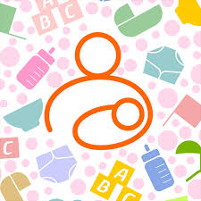](http://android.babytrackers.com/)Health apps for women’s health can be divided into four main groups, according to their purpose: Menstrual Cycle and Contraception; Pregnancy and Post-partum; Screening and Prevention; Perimenopause and Menopause.

https://app.flo.health/

**Health Apps for Children’s Care**

These applications are intended to help new parents in the care of new-born’s in areas like daily logs, feeding, paediatric advice, sleep habits, breastfeeding.

http://android.babytrackers.com/

[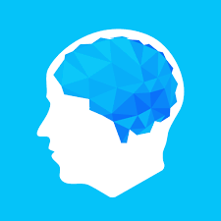](https://elevateapp.com/)**Health Apps for the Elderly**

There are plenty of health apps available for the elderly. Some are addressing the physical and mental fitness of its users while others have a clear medical implication with the purpose of managing a chronic illness or disability.

https://elevateapp.com/

[](https://apps.apple.com/us/app/breathe2relax/id425720246)**Health Apps for Mental Health**

Health apps for mental health problems encompasses a broad range of applications, like recording of the user's mood and day to day life; tools for PTSD, anxiety and stress management; helping to seek psychological support, as well as teaching and informing professionals; helping to manage emotions and feelings.

https://apps.apple.com/us/app/breathe2relax/id425720246

**Apps for Healthcare Services**

The healthcare systems of European countries offer a wide range of support in their services through digital tools. This includes tools for enhancing access to the system, contact with health professionals, or purchase of medicines, among others. You will find specific information of the key characteristics of the health services and related digital tools in Spain, Germany, France, Greece, Cyprus, and Italy here (in English language): https://training.apps4health.eu/courses/TMA114/.

Have fun and gain useful insights while exploring the health apps!